**Choose the letter of the correct answer. In all cases, E) NOTA means “none of these answers”.**

1. Add the following fractions to see how many countries make up North America:



**A. 4 B. 23 C. 31 D. 130 E. NOTA**

2. North America covers about 5% of the planet's surface. What is 5% of 250?

**A. 5 B. 12.5 C. 25 D. 1250 E. NOTA**

3. Which North American flag is symmetric about the line of symmetry shown?

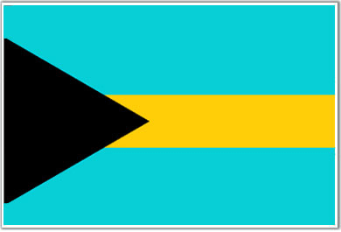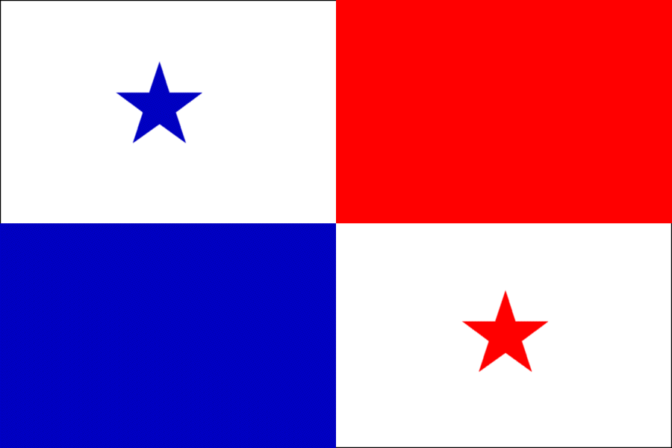 **A. C.**

**B. 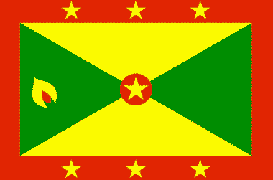 D. **

**E. NOTA**

4. St. Augustine was the first European settlement in the U.S. A fort was built there with four equal sides and two different pairs of congruent angles. What shape is the fort?

**A. Square B. Rhombus C. Pentagon**

**D. Parallelogram E. NOTA**

For questions 5-7 refer to the given information:

The five cities in the United States with the largest population are New York City with 9 million inhabitants, Los Angeles with 4 million inhabitants, Chicago with 3 million, Houston with 2 million, and Philadelphia with 2 million.

5. What is the mean number of inhabitants in the five most populous cities (in millions of people) in the United States?

**A. 4 B. 5 C. 9 D. 20 E. NOTA**

6. What is the median number of inhabitants in the five most populous cities (in millions of people)?

**A. 2 B. 3 C. 4 D. 9 E. NOTA**

7. What is the mode of inhabitants in the five most populous cities (in millions of people)?

**A. 2 B. 3 C. 4 D. 9 E. NOTA**

8. If a man wishes to tightrope walk across the Grand Canyon at the widest point, where it is 18 miles wide, how many miles must the tightrope be for him to cross 2.5 times? (he can't walk on the same rope twice)

**A. 13.5 miles B. 27 miles C. 36 miles D. 45 miles E. NOTA**

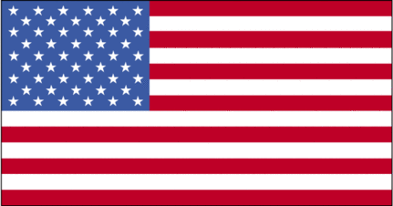9.

6 ft.

Referring to the image to the left:

4 ft.

Find the perimeter. Find the area. Add your two answers. What do you get (not minding units)?

**A. 20 B. 24**

**C. 44 D. 48**

**E. NOTA**

10. If it took 526 boards to make  of the Coney Island board walk, how many boards did it take to make the entire walk?

**A. 131.5 boards B. 1583 boards C. 2104 boards**

**D. 6900 boards E. NOTA**

11. From Tallahassee, FL to Houston, TX, the time difference is one hour (Tallahassee is one clock hour ahead of Houston) and the drive time is 14 hours. If you are driving from Houston to Tallahassee, and you leave at 9 p.m. local time, what time will you arrive in Tallahassee (Tallahassee time)?

**A. 9:00 a.m. B. 10:00 a.m. C. 11:00 a.m.**

**D. noon E. NOTA**

12. Which of these presidential images is not carved into Mt. Rushmore?

**A. Jackson B. Jefferson C. Roosevelt D. Washington E.NOTA**

13. A redwood tree has a diameter of 30 ft. What is the area of a circular cross section of the trunk, in square feet?

**A. 15π B. 90 π C. 225 π D. 900 π E. NOTA**

14. The chance that it will rain in Batagues, Mexico is 1%. What are the odds that it will rain?

**A. 1: 100 B. 1:99 C. 1:90 D. 1:9 E. NOTA**

15. You have 10 U.S. dollars and you wish to purchase a trinket in Barbados that costs 5.28 Barbados dollars. If every 1 U.S. dollar = 2 Barbados dollars how many U.S. dollars will you have after your purchase?

**A. $7.26 B. $7.36 C. $14.72 D. $14.82 E. NOTA**

16. There are 32 fishermen in Barbados and 523 fish. If all of the fishermen must catch the same number of fish, and they wish to catch as many fish as possible, how many fish will remain uncaught? (find the remainder)

**A. 10 fish B. 11 fish C. 15 fish D. 16 fish E. NOTA**

17. In the Bahamas, conch is a popular food. Conch shells also happen to follow Fibonacci sequence. Fins the sum of the missing numbers in this conch sequence:

1, 1, 2, __, 5, 8, __, __

**A. 14 B. 25 C. 36 D. 37 E. NOTA**

18. In Belize, there is a zip line that is 500 ft. long. If the average person goes down the zip line in 30 seconds, how fast does the average person travel?

**A.  B.  C.  D.  E. NOTA**

19. The distance from Port-au-Prince, Haiti to Havana, Cuba is 723 miles. The distance from Havana, Cuba to Miami, Florida is 228 miles. What is the distance from Port-au-Prince, Haiti to Miami, Florida if you follow these routes?

**A. 495 miles B. 500 miles C. 951 miles D. 1000 miles E. NOTA**

20. If a boat can get through the Panama Canal in 5 minutes 30 seconds, how many whole boats can be sent through in 26 minutes?

**A. 3 boats B. 4 boats C. 5 boats D. 6 boats E. NOTA**

21. On the first jump a jumping bean jumps 1 ft due east, on the second jump 2 ft due east, on the third jump 3 ft due east. If the pattern continues, how far will the bean be from its starting point after the 10th jump? (the bean moves in a straight line)

**A. 10 ft. B. 20 ft. C. 45 ft. D. 55 ft. E. NOTA**

22. In México, an enchilada costs 3.22 pesos, a quesadilla costs 4.04 pesos, and a burrito costs 5.67 pesos. If you buy 2 burritos, 4 quesadillas, and 3 enchiladas and pay with 50 pesos how much change will you receive?

**A. 6.32 pesos B. 12.84 pesos C. 37.16 pesos D. 43.68 pesos E. NOTA**

23. A Mexican corn farmer is trying to figure out how much corn he has to harvest. If he has 100 plants which are numbered consecutively from 1-100, and he can't use the prime numbered crops, how many corn plants can he harvest?

**A. 25 B. 26 C. 74 D. 75 E. NOTA**

24. Although many countries are part of North America, they still don't have everything in common. What is the Least Common Multiple (LCM) of 18, 36, and 72?

**A. 2 B. 9 C. 18 D. 72 E. NOTA**

25. The line to go to the Toronto Film Festival has a wait time of an hour long. If  of the line leaves, and then of the  who left immediately returns, how long is the wait time from the very end of the new line?

**A. 45 minutes B. 52 minutes C. 1 hour**

**D. 1 hour 15 mins E. NOTA**

26. If the annual exported amount of maple syrup (in millions of gallons) is expressed by the expression



how many million gallons of maple syrup are exported annually?

**A. -256 B. -32 C. 32 D. 256 E. NOTA**

27. What symbol is featured on the Canadian flag?

**A. Gummy Bear B. Hockey Puck C. Mounty Hat D. Snowman E. NOTA**

28. The CN Tower in Canada is the tallest building in North America at 1815 feet tall. How many miles tall is the building?

**A.  B.  C.  D.  E. NOTA**

29. A shipping boat must go to Narsaq, Greenland from Halifax, Canada and then return to Halifax. If the boat gets 200 km per liter of gas, and the boat holds 12 liters of gas, how far will the boat make it back to Canada before it has to refill if it is 2000 km from Narsaq to Halifax?

**A. 400 km B. 600 km C. 2400 km D. 4000 km E. NOTA**

30. Which city in North America has the largest population?

**A. Mexico City B. New York City C. Quebec City D. Tallahassee E. NOTA**